This assignment calls for me to explain to a non-technical co-worker how I will go about planning a business intelligence (BI) solution. First I will describe an imaginary new BI solution and then I will explain how I will begin the planning process for it.

Here is a description of the proposed new BI solution:

***Scenario: IMS Help Tickets***

*At my work, a team of trained volunteers serve as superusers for our audit management application called IMS. Any IMS user with an issue or question may submit a help ticket by phone or online to request assistance from an IMS superuser. Unless the user asks for a specific superuser, the help desk coordinator will make the superuser assignment based on geographic location. The assigned superuser will troubleshoot the user’s issue and attempt to resolve it. If the superuser cannot resolve the issue due to lack of expertise or insufficient permissions on the system, he or she will contact the help desk coordinator to request elevation of the issue to an IMS expert. As soon as the issue is resolved by either the superuser or the expert, the superuser reports back to the help desk coordinator about details of the issue and resolution of the ticket.*

*Records of IMS help ticket transactions are kept in an electronic database system. My preliminary review of this database revealed these details about records that might be included in the new BI solution:*

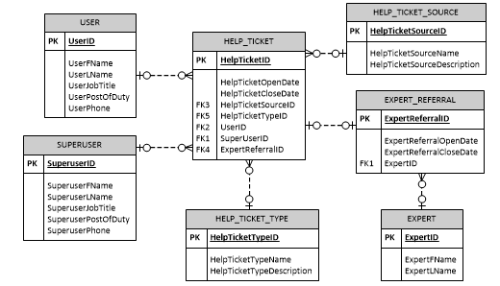

*There is not currently a formal reporting system in place for IMS help tickets. The client (help desk management) would like a BI solution that provides them with accurate information about IMS help ticket transactions.*

Here is an explanation of how I will start planning the new BI solution:

**Planning Process: IMS Help Ticket Solution**

This flowchart from Figure 3-1 of the class textbook illustrates the approach I will take to planning this solution. Of particular note are the “Can it be done?” checkpoints after each of the first three phases. A “no” answer at any one of these checkpoints will require me to restart the planning from scratch.

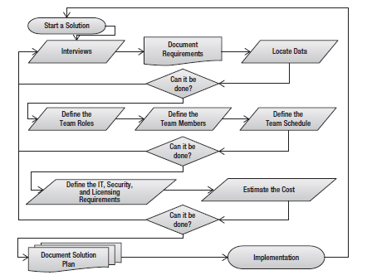

Applying this methodology to the IMS Help Ticket scenario, I will plan the proposed solution in four pre-implementation phases. All of this planning will be documented in a BI Solution Plan and Solution Development Plan as described in the class textbook.

Phase I: Understand the data and the client’s need for the BI solution

* Interview the client about why they need the BI solution and what they want it to accomplish.
* Interview IMS superusers, experts, and help desk coordinators for an understanding of the available data in the system and how it is managed and stored.
* Interview IT personnel for technical details about the data. Find out about special security or compliance concerns.
* Examine all tables and fields associated with the data and determine which are important to the proposed solution.

Phase II: Build the solution team and determine a schedule for the project

* Considering what has been learned about the proposed solution in Phase I, determine what roles will be needed on the team.
* Find team members who have availability during the project period. Look for people with diverse skills so that they may be assigned several roles on the team.
* Develop a schedule that accomplishes implementation of the solution within the necessary timeframe.

Phase III: Determine infrastructure needs and estimated cost of the project

* Define the IT, security, and licensing requirements for the solution.
* Prepare a detailed cost estimate to build the solution, considering the build team, the schedule, and the infrastructure requirements involved.

Phase IV: Prepare the plan of action

* Finalize the formal plan and share it with the client.

* * * * *